

Bolton Parish Church School – Attendance Policy

Throughout this policy we actively promote the Christian Values of RESPECT, FRIENDSHIP, LOVE, PEACE, RESPONSIBILITY, THANKFULNESS and FORGIVENESS

At Bolton Parish Church C of E Primary School we expect all our pupils to take full advantage of the educational opportunities available to them. Poor attendance and punctuality can adversely affect pupil, class, and school performances and may also have potential longer term consequences. We aim to encourage excellent levels of attendance and punctuality and have appropriate procedures in place to deal with such matters.

We believe that the most important factor in promoting school attendance is the development of positive attitudes towards school. To this end, we strive to make our school a happy and rewarding experience for all our children.

Statutory Framework
Under the 1996 Education Act, a pupil is required to attend where they are a registered pupil. By law, all children of compulsory school age (between 5 and 16) must receive a suitable education. Schools are open for 190 days each year and all pupils have the right to their 190 days of teaching and learning and a wider school experience.

Rights and Responsibilities
Ensuring all pupil have excellent school attendance and punctuality is the responsibility of parents/carers, all school staff, the wider community and pupils themselves.

Pupils
All pupils are expected to attend school regularly and punctually. Pupils, who, for whatever reason, experience attendance difficulties, will be offered a range of support. They will be encouraged to talk through any problems and if necessary, parents will be contacted. Pupils with consistently good attendance or pupils who have overcome significant difficulties around attendance will be praised or rewarded.

Parents
Section 7 of the Education Act 1996 places a duty on parents to ensure their children of compulsory school age have access to full time education. Where a pupil is registered at a school the parent(s) is responsible for ensuring the child attends regularly and punctually.
As the parent you are committing an offence if you fail to make sure that your child attends school regularly and the absence is unauthorised by the Headteacher, even if they are missing school without your knowledge.

If you fail to ensure your child’s regular attendance at school the Local Authority may issue a penalty notice or instigate legal proceedings for an offence under section 444 of the Education Act 1996. (for more information about penalty notices seehttps://www.bolton.gov.uk/downloads/file/163/penalty-notice )

What is regular attendance?

In April 2017, the Supreme Court held that attending school “regularly” means attendance in accordance with the rules prescribed by the school and not “sufficiently frequent attendance“. This means that a child must attend school on every day that the school requires him or her to do so and failure to do this may lead to the commission of an offence.

Attendance and Punctuality
The primary responsibility for ensuring that their child attends school regularly and arrives on time rests with parents/carers. They must also ensure their child is properly dressed, equipped with learning material and in a fit condition to learn.

Attendance and punctuality can be vulnerable to a wide range of school, home based or community factors.

Children who are in the habit of staying up late or regularly missing breakfast may be tired at the start of the day and therefore are not in a fit condition to learn.

If a child is prevented for any reason from attending school or is late, parents must notify the school as soon as possible by telephone and/or writing.

A child’s absence from school will be considered as unauthorised until a satisfactory explanation is provided from the parent/carer.

Parents/carers will be notified promptly of any concerns relating to their child’s attendance or punctuality. Communication to parents/carers regarding such matters may include phone calls, letters, or a home visit from the School Social Worker.

Appointments
Parents should avoid, if at all possible, making dental/medical appointments for their children during school hours. Parents will be encouraged to make routine appointments during school holidays or after school hours. If a parent chooses to make an appointment during the school day, they should provide proof of the child’s appointment for the school e.g. letter, appointment card etc. Family bereavement or taking part in an agreed religious observation would be acceptable for short absences but must, when possible, be requested in advance. Unacceptable reasons for children missing school include shopping and birthdays.

Holidays in Term Time
Parents do not have the legal right to take children out of school on holiday. School have received clear instructions from the government stating the following:
Amendments have been made to the 2006 regulations removing references to family holidays and extended leave as well as the discretionary threshold of 10 school days. The amendments made clear that the Head Teacher may not grant any leave of absence during term time unless there a ‘exceptional circumstances’. These amendments came into force on the 1st September 2013.

This means that, from 1st September, 2013, Head Teachers have no longer been able to authorise any term time absence unless it has been deemed to be an ‘exceptional circumstance’ and evidence has been provided.

See https://www.gov.uk/school-attendance-absence/overview for further information.

The decision to authorise absence is at the Head Teacher’s discretion based on their assessment of the situation.

Term times are for education. This is the priority. Children and families have 175 days off school per year including weekends and school holidays. If an event can reasonably be rescheduled outside term time then it is likely to be an unauthorised absence. Absence during term time for holidays will therefore not be considered as an ‘exceptional circumstance’.

In all circumstances, parents/carers will be asked to provide evidence to support their application.

The Head Teacher can determine the length of the authorised absence as well as whether the absence is authorised at all.

The fundamental principles for defining ‘exceptional’ are: rare, significant, unavoidable and short (by ‘unavoidable’ we mean an event that could not be reasonably scheduled at another time).

Parents who take their children on holiday without permission could be issued with a penalty notice from the local authority. If the penalty notice is left unpaid, this could result in a prosecution through the courts.

Traveller Pupils Requests for Absence
Parents/carers are required to inform school of any absences preferably a term before the absence. This is so that school can be prepared to set online work for your child to complete whilst away to avoid any gaps in their education. Failure to do this will result in your child`s absence being recorded as unauthorised.

Please see the Department for Education (DfE) guidance on Traveller absence below.

Code T: Gypsy, Roma and Traveller absence
A number of different groups are covered by the generic term Traveller – Roma, English and Welsh Gypsies, Irish and Scottish Travellers, Showmen (fairground people) and Circus people, Bargees (occupational boat dwellers) and New Travellers.

This code should be used when Traveller families are known to be travelling for occupational purposes and have agreed this with the school but it is not known whether the pupil is attending educational provision. It should not be used for any other types of absence by these groups.

To help ensure continuity of education for Traveller children it is expected that the child should attend school elsewhere when their family is travelling and be dual registered at that school and the main school. Children from these groups whose families do not travel are expected to register at a school and attend as normal. They are subject to the same rules as other children in terms of the requirement to attend school regularly once registered at a school

As stated in this guidance absence for travelling for occupational purposes has to be agreed with school before the absence is taken. Therefore we require notice to be given every term and the absence discussed with school for the absence code T to be used. If notice for traveller absence is not given then the absence will be classed as unauthorised.

Registration
Morning registration begins at 8.45am and ends at 8.55 am.

Registers will be marked in accordance with the regulation and symbols as set out by the DfE to be used from September 2007.

Entrances around school will remain open until 8.50 am. Any pupil arriving after this time must report to the main office and will be marked as late in the register. Children arriving after registration has closed will be marked as late (unauthorised). If a child is late for school (after 9.00am), it is the parents/carers responsibility to inform the school as to the reason why their child is late. Parents/carers can either accompany their child into school (for all children in Early Years or Key Stage 1) or contact the school office by phone (only for children in Key Stage 2 who walk to school unaccompanied).

Registers are monitored daily and can act as the initial warning system for a number of issues which may affect the child’s welfare including truancy, child protection, illness and a range of home and school based issues.

Procedures for following up absences
Should a child be absent from school, then the parent must ensure that school is informed as early as possible on the first day of absence and then on any subsequent days. This can be done personally by calling in at school, by telephone (including leaving an answer machine message) or by a note. A verbal message via another child is not sufficient. Parents will also appreciate the importance of this with regard to their child’s safety. A signed and dated note of explanation sent on the child’s return to school is also appreciated.

Every attempt will be made by the school’s Attendance Officer to determine why a child was absent from school, this will include a visit to the family home by the school’s Attendance Officer on the fourth day of absence. A home visit may also be completed in cases where the child has poor attendance or other professional agencies are involved. Parents will also receive a text message informing them of their child’s current attendance data in cases of attendance below 96%.

If after a week, no information is received from the parent/carer, then the child’s absence will be marked as unauthorised. A rigorous and robust system is in place to monitor children’s attendance and punctuality. Data is collected at the end of each half term so that steps can be put in place to address any concerns regarding a child’s attendance/punctuality and also to measure progress towards agreed targets.

Strategies
A varied and flexible curriculum will be offered to all pupils. Every effort will be made to ensure that learning tasks are matched to pupil’s needs.

- Medical evidence must be provided when requested by the School Attendance Officer
- Every effort will be made to resolve any issues of bullying in accordance with the anti-bullying policy.
- Parents will be reminded regularly via newsletters, parents evening etc, of the importance of good attendance and punctuality.
- Staff will complete registers accurately for each session and will bring to the School Attendance officer’s attention any absences that are cause for concern or suspicious.
- The School Attendance officer will meet regularly with the Head Teacher and other professionals in order to identify, assess and support those pupils who are experiencing attendance difficulties.
- Pupils arriving late will be reported to the School Attendance Officer and a record kept of the times and occasions that the pupil is late.
- Parents /carers will be asked to telephone or notify the school if their child is absent or ill.
- When a child is absent, the school office will first telephone the parent/carer asking them to contact the school if they have not notified the school that their child is absent.
- Where a pupil is developing a pattern of occasional absences the parent/carer will be contacted to discuss the pattern.
- The School Attendance Officer will follow up absences that are suspicious or causing concern.
- Parents will be informed by letter if their child’s attendance is causing a concern.
- Parents may be requested to attend an attendance meeting with the School Attendance Officer.
- Where persistent absence remains a concern, parents will be invited to meet with an attendance panel of governors
- Where necessary the school will work closely with the local authority and take legal action against parents/carers unlawfully keeping their children from school.
- Attendance data will be regularly collected and analysed in order to help identify patterns, set targets, correlate attendance with achievement, and support and inform policy/practice.
- The Head Teacher will issue an annual report to the school’s governing body on attendance matters.
- The Head Teacher will report annually to governors on attendance figures and patterns of absence.
- Good or greatly improved attendance will be recognised and rewarded.

Outcomes
The school will do all it can to ensure that pupils come happily, willingly, regularly and punctually to ensure that they gain the greatest possible value from their education.

Adopted by the Governing body March 2023.

Appendix 1.

TRAVELLER APPLICATION FOR ABSENCE FROM SCHOOL

Please see the Department for Education (DfE) guidance on Traveller absence below.

Code T: Gypsy, Roma and Traveller absence
A number of different groups are covered by the generic term Traveller – Roma, English and Welsh Gypsies, Irish and Scottish Travellers, Showmen (fairground people) and Circus people, Bargees (occupational boat dwellers) and New Travellers.

This code should be used when Traveller families are known to be travelling for occupational purposes and have agreed this with the school but it is not known whether the pupil is attending educational provision. It should not be used for any other types of absence by these groups.

To help ensure continuity of education for Traveller children it is expected that the child should attend school elsewhere when their family is travelling and be dual registered at that school and the main school. Children from these groups whose families do not travel are expected to register at a school and attend as normal. They are subject to the same rules as other children in terms of the requirement to attend school regularly once registered at a school

As stated in this guidance absence for travelling for occupational purposes has to be agreed with school before the absence is taken. Therefore we require notice to be given every term and the absence discussed with school for the absence code T to be used. If notice for traveller absence is not given then the absence will be classed as unauthorised.
Parents’ Section - (Please use block capitals)
Name of Child ______________________________________________________________
Date of Birth _____________________ Class _______________
Surname of parent/carer ___________________________ First name _________________________
Home telephone number ____________________ Mobile number ___________________________
Destination _____________________________________________________________________________________
______________________________________________________________________________________________
Date of departure ______________________ Date of return to school ________________________
Length of absence (number of school days) __________________
Details of Educational Provision _____________________________________________________________________
Parents’/Carers signature __________________________________________________________________________
For Office Use: Date of meeting at school _______________________________________________
Outcome of meeting ______________________________________________________________________________
_______________________________________________________________________________________________
Signed (staff member) _______________________________________________________________
Appendix 2.
Below 96% Letter
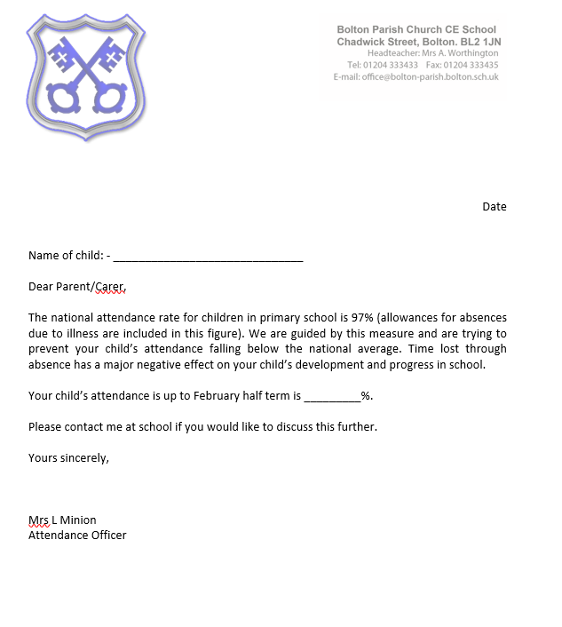

Appendix 3.
Below 90% Letter
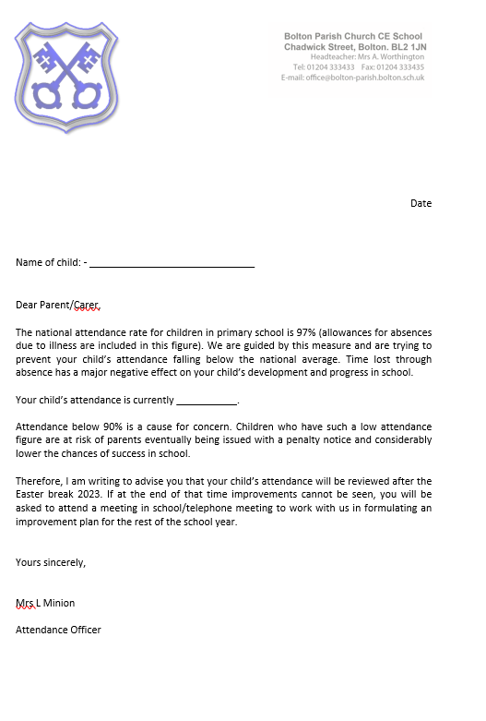

Appendix 4.
Holiday Request Refusal Letter
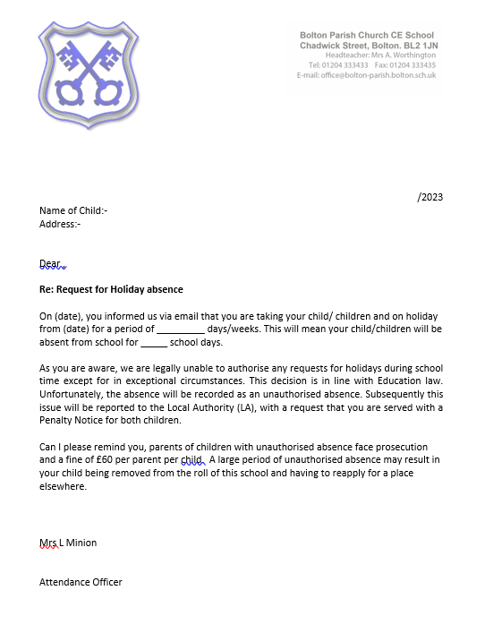

Appendix 5.
Punctuality Letter

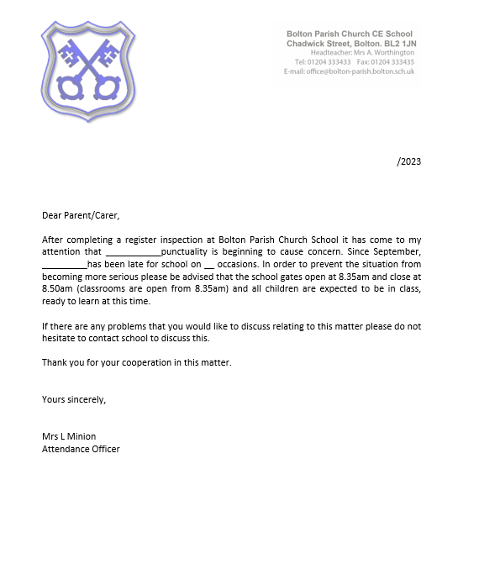

Appendix 6
Unauthorised Attendance Warning

